Cumberland Educational Foundation
Inspiring Excellence, One Grant at a Time

2020 Annual Report

Greetings from the Cumberland Educational Foundation. I hope this letter finds you and yours enjoying the sunshine and transition to spring in the Northwoods.
As we are all aware, 2020 threw us for a loop. I am fairly confident that we have all been affected by these unprecedented times in one way or another, and that holds true for The Educational Foundation as well. Despite the cancellation of the 2020 Light A Legacy event, we feel grateful for the funds that were still donated. It is truly the giving nature of our community that allows for groups such as ours to unite and overcome challenges, all for the good of our youth.
It has been a great pleasure to be a part of the Cumberland Educational Foundation. In the fall of 2020, we held our annual meeting, postponed due to the pandemic. We welcome back Vice President, Casey Morrison, whose term was extended one year; Secretary, DeAnn Walters; Treasurer, Shay Horton; and trustees, Erica Donatelle, Travis Erickson, Dr. Barry Rose and Kellsey Ruppel. Please join me in extending a heartfelt thank you to Jon Hile for his years of dedicated service to the foundation. One of the many reasons for the success of the Cumberland Educational Foundation is the spirit of service exemplified by the leadership of the Board of Directors. We have a loyal group of volunteers - from our trustees to those who work on the Light A Legacy banquet - who continue to give their time and talents to the foundation. The creativity of the staff who continue to bring forth brilliant ideas for enriching the education of Cumberland’s students is incredible.
The Board of Trustees is excited to announce the 2021 grant recipient, Ryan O’Connell, and his proposal for the Disc Golf Course. This project is designed to promote the activity of disc golf, highlighted by exercise benefits, social interaction, and enjoyment. The grant is aimed to upgrade the current disc golf course near Endeavor Field as well as add a disc golf course at Islander Park. The course will include permanent tee boxes, appropriate signage, as well as new baskets. The updated venues will be a great opportunity to showcase the beautiful facilities we have right here in our community.

To date, alumni and friends have raised over $515,000 for the Foundation with $242,000 being awarded in grants. This could only be made possible by your generous and unwavering support. You all play a vital role in the success of the Cumberland School District. In closing, it is a true honor to be a part of the Cumberland Educational Foundation, and furthermore, a member of this community. I believe we have given our children outstanding educational opportunities and have inspired them to become exceptional people!

Respectfully submitted,
Ashley Knutson, President

The 2020-2021 Board of Directors for the Cumberland Educational Foundation
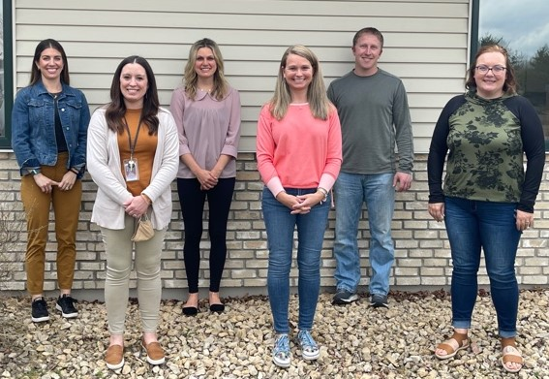
President, Ashley Knutson; Vice President, Casey Morrison; Trustee, Kellsey Ruppel; Secretary, DeAnn Walters; Trustee, Travis Erickson; Treasurer, Shay Horton.
Not pictured: Erica Donatelle & Dr. Barry Rose

Please mark your calendar for the 18th Annual
Light a Legacy Dinner – A Virtual Event!
May 12 – May 22, 2021

For more information, please contact
Melissa Weaver at 715-822-5124

